Need to set ZIPFILE( or any name)

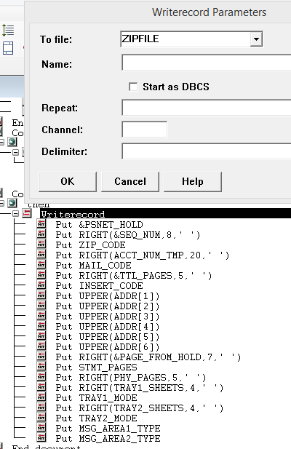

Formatgroup: (ZIPFILE configuration)

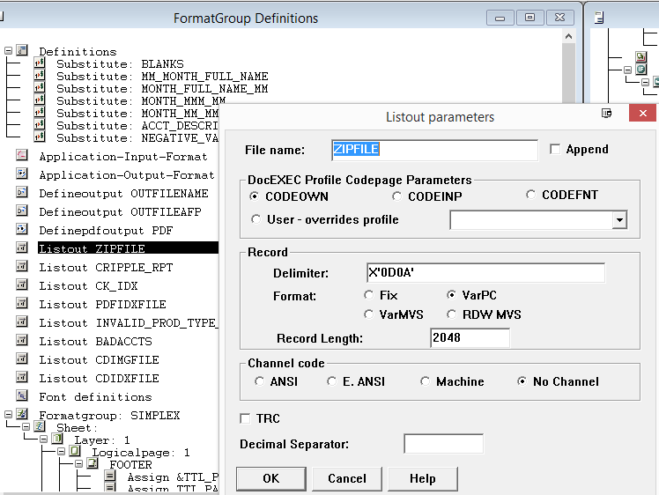

ZIPFILE set this as Environment Variable and gives a value( This value will be the output file for ‘s’ option)

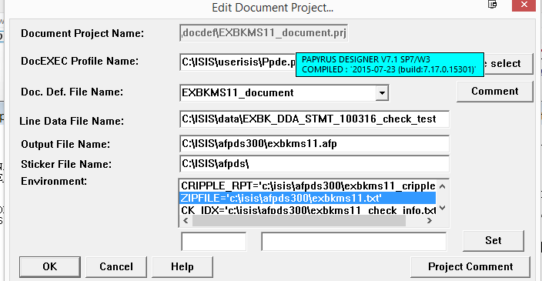

Code( use the below code in Document Format Definitions for job type ‘s’, might need some change based on project requirements). If it is a statement then use Code For Statement or if it is daily then use Code For Dalily:

Code For Statement:

**IF &JOB_TYPE=='s' ;**

**THEN ;**

**WRITERECORD TO ZIPFILE ;**

**/*This information needs for mailing purpose*/**

**PUT &PSNET_HOLD START 1 LENGTH 12;**

**/*What number customer this is, should be right align*/**

**PUT RIGHT(&SEQ_NUM,8,' ') START 15 LENGTH 8;**

**/*zip code*/**

**PUT ZIP_CODE START 23 LENGTH 10;**

**/*Account number , no leading zeros, must be right aligned*/**

**/*If member number is present then it gets priority over Account number here*/**

**PUT RIGHT(ACCT_NUM_TMP,20,' ') START 33 LENGTH 20;**

**/*mail code , whether it wil be suppressed or else*/**

**PUT MAIL_CODE START 53 LENGTH 1;**

**/*Total logical pages of a customer, must be right aligned*/**

**PUT RIGHT(&TTL_PAGES,5,' ') START 54 LENGTH 5;**

**/*Insert code , which insert bin to be used*/**

**PUT INSERT_CODE START 59 LENGTH 5;**

**/*adress1 most of the case it's the name, a customer may have highest 6 address*/**

**PUT UPPER(ADDR[1]) START 64 LENGTH 40;**

**PUT UPPER(ADDR[2]) START 104 LENGTH 40;**

**PUT UPPER(ADDR[3]) START 144 LENGTH 40;**

**PUT UPPER(ADDR[4]) START 184 LENGTH 40;**

**PUT UPPER(ADDR[5]) START 224 LENGTH 40;**

**PUT UPPER(ADDR[6]) START 264 LENGTH 40;**

**/*starting logical page number of customer*/**

**PUT RIGHT(&PAGE_FROM_HOLD,7,' ') START 304 LENGTH 7;**

**/*total logical pages excluding check images*/**

**PUT STMT_PAGES START 318 LENGTH 5;**

**/*Total physical pages( one logical page1 and one logical page2 form one physical page)*/**

**PUT RIGHT(PHY_PAGES,5,' ') START 351 LENGTH 5;**

**/*Total sheets or physical pages use from Tray1, there may be 5 trays, but most of the cases we saw 2*/**

**PUT RIGHT(TRAY1_SHEETS,4,' ') START 356 LENGTH 4;**

**/*Tray1 mode 's' for simple, 'd' for duplex*/**

**PUT TRAY1_MODE START 360 LENGTH 1;**

**/*Total sheets or physical pages use from Tray2*/**

**PUT RIGHT(TRAY2_SHEETS,4,' ') START 361 LENGTH 4;**

**/*Tray2 mode 's' for simple, 'd' for duplex*/**

**PUT TRAY2_MODE START 365 LENGTH 1;**

**/*for message manager, message1 type, '1' for fixed message*/**

**PUT MSG_AREA1_TYPE START 411 LENGTH 1;**

**/*for message manager, message2 type, '1' for fixed message*/**

**PUT MSG_AREA2_TYPE START 412 LENGTH 1;**

**ENDIO;**

**ENDIF ;**

Code For Dalily:

**IF &JOB_TYPE=='s' ;**

**THEN ;**

**WRITERECORD TO ZIPFILE ;**

**/*This information needs for mailing purpose*/**

**PUT &PSNET_HOLD START 1 LENGTH 12;**

**/*What number customer this is, should be right align*/**

**PUT RIGHT(&SEQ_NUM,8,' ') START 15 LENGTH 8;**

**/*zip code*/**

**PUT ZIP_CODE START 23 LENGTH 10;**

**/*Account number , no leading zeros, must be right aligned*/**

**/*If member number is present then it gets priority over Account number here*/**

**PUT RIGHT(ACCT_NUM_TMP,20,' ') START 33 LENGTH 20;**

**/*mail code , whether it wil be suppressed or else*/**

**PUT MAIL_CODE START 53 LENGTH 1;**

**/*Total logical pages of a customer, must be right aligned*/**

**PUT RIGHT(&TTL_PAGES,5,' ') START 54 LENGTH 5;**

**/*Insert code , which insert bin to be used*/**

**PUT INSERT_CODE START 59 LENGTH 5;**

**/*adress1 most of the case it's the name, a customer may have highest 6 address*/**

**PUT UPPER(ADDR[1]) START 64 LENGTH 40;**

**PUT UPPER(ADDR[2]) START 104 LENGTH 40;**

**PUT UPPER(ADDR[3]) START 144 LENGTH 40;**

**PUT UPPER(ADDR[4]) START 184 LENGTH 40;**

**PUT UPPER(ADDR[5]) START 224 LENGTH 40;**

**PUT UPPER(ADDR[6]) START 264 LENGTH 40;**

**/*starting logical page number of customer*/**

**PUT RIGHT(&PAGE_FROM_HOLD,7,' ') START 304 LENGTH 7;**

**/*Letter Code*/**

**PUT &LTR_CODE START 312 LENGTH 3;**

**/*Afp code*/**

**PUT &AFP_CODE START 315 LENGTH 3;**

**/*total logical pages excluding check images*/**

**PUT STMT_PAGES START 318 LENGTH 5;**

**/*Enotice Date no dash/slash allowed here format mmddyyyy*/**

**PUT ENOTICE_DATE START 323 LENGTH 8;**

**/*if letters customer forms a group Group, this is total image/logical page for all customers of that group*/**

**PUT GROUP_IMAGE_COUNT START 335 LENGTH 5;**

**/*if letters customer forms a group Group, this is total image/logical page for all customers of that group*/**

**PUT RIGHT(GROUP_SHEET_COUNT,5,' ') START 345 LENGTH 1;**

**/*if estatement needs to be suppressed*/**

**PUT E_SUPPRESSED_FLAG START 340 LENGTH 5;**

**/*Total physical pages( one logical page1 and one logical page2 form one physical page)*/**

**PUT RIGHT(PHY_PAGES,5,' ') START 351 LENGTH 5;**

**/*Total sheets or physical pages use from Tray1, there may be 5 trays, but most of the cases we saw 2*/**

**PUT RIGHT(TRAY1_SHEETS,4,' ') START 356 LENGTH 4;**

**/*Tray1 mode 's' for simple, 'd' for duplex*/**

**PUT TRAY1_MODE START 360 LENGTH 1;**

**/*Total sheets or physical pages use from Tray2*/**

**PUT RIGHT(TRAY2_SHEETS,4,' ') START 361 LENGTH 4;**

**/*Tray2 mode 's' for simple, 'd' for duplex*/**

**PUT TRAY2_MODE START 365 LENGTH 1;**

**/*for message manager, message1 type, '1' for fixed message*/**

**PUT MSG_AREA1_TYPE START 411 LENGTH 1;**

**/*for message manager, message2 type, '1' for fixed message*/**

**PUT MSG_AREA2_TYPE START 412 LENGTH 1;**

**/*Just need to fill this field to avoid some error in back end*/**

**PUT FILLER START 381 LENGTH 1;**

**ENDIO;**

**ENDIF ;**